 

**SIMATS ENGINEERING SAVEETHA INSTITUTE OF MEDICAL AND**

**TECHNICAL SCIENCE**

# **CSA1484-**Complier Design for Deep Learning Models

Cross compiler development in compiler design Submitted by

M Ganga Dinesh Reddy, Mohamed Bayaz. A, V. Praveen

(192211451)

(192224007)

(192221006)

Institute of Computer Science and Engineering SAVEETHA SCHOOL OF ENGINEERING

# CHENNAI-602105

TAMILNADU, INDIA



|  |  |  |
| --- | --- | --- |
| **S.NO** | **TOPIC** | **PG NO** |
| 1 | OBJECTIVES | 3 |
| 2 | INTRODUCTION | 3 |
| 3 | EXISTING SYSTEM | 3-4 |
| 4 | LITERATURE SURVEY | 4 |
| 5 | DESIGN | 5 |
| 6 | ANALYSIS | 6 |
| 7 | RESULT | 7 |
| 8 | CONCLUSION | 7 |
| 9 | REFERENCES | 7 |

## OBJECTIVES:

The primary objective of cross-compiler development is to streamline the creation of software capable of running on target platforms with differing architectures or operating systems compared to the development environment. By enabling developers to write and compile code on one system while generating executable binaries for another, cross-compilation fosters platform portability, ensuring software can be deployed across a diverse array of devices and systems. This approach is particularly valuable in embedded systems development, where resources are often limited, and specialized architectures prevail. Through cross-compilation, developers can optimize performance, reduce memory usage, and tailor software to meet the unique requirements of embedded applications.

## INTRODUCTION:

Cross-compiler development is a pivotal facet of software engineering, aiming to facilitate the creation of applications destined for execution on platforms with architectures or operating systems differing from the development environment. Its essence lies in the ability to compile code on one system, the host, while generating executable files suitable for another, known as the target. This method ensures platform versatility, enabling software to transcend the confines of specific hardware or software configurations. Particularly indispensable in embedded systems, where resources are constrained, cross-compilation optimizes performance, minimizes memory usage, and tailors software to fit the idiosyncrasies of specialized architectures.

## EXISTING SYSTEM:

Developing a cross-compiler for an existing system involves adapting or extending an existing compiler toolchain to generate executable code for a different target architecture or operating system. This process typically entails configuring the compiler, linker, and other tools to understand the specifics of the target platform's instruction set, memory layout, and calling conventions. Additionally, developers often need to port or provide support for standard libraries and headers tailored to the target environment. Testing and debugging are critical phases to ensure the generated code functions correctly on the target system.

Throughout the development process, documentation and support materials help users understand how to utilize the cross-compiler effectively. Overall, cross-compiler development demands a deep understanding of both the source and target platforms to facilitate seamless code generation and deployment across diverse computing environments.

## LITERATURE SURVEY:

A literature survey on cross compiler development encompasses a wide array of research focusing on the creation, optimization, and application of compilers capable of generating code for platforms distinct from the development environment. Scholars investigate fundamental compiler construction principles, including lexical analysis, parsing, optimization, and code generation, while also examining advanced techniques such as intermediate representations (IRs) and optimization strategies tailored for cross-compilation. The survey explores the landscape of cross-compilation toolchains, evaluating popular options like GCC, LLVM/Clang, and Microsoft Visual Studio Cross Tools in terms of features, performance, and platform support. Moreover, it delves into target architecture intricacies, including considerations like endianess, memory layout, and instruction set architecture (ISA), alongside strategies for porting libraries, optimizing code, and ensuring compiler correctness through comprehensive testing methodologies. Case studies provide valuable insights into practical applications, spanning diverse domains such as embedded systems, game development, and cross- platform software frameworks. As the field evolves, researchers identify emerging trends and future research directions aimed at addressing scalability, efficiency, and usability challenges inherent in cross-compiler development. Through this survey, a comprehensive understanding of the critical role played by cross-compilation in facilitating software deployment across heterogeneous computing environments emerges, laying the groundwork for further innovation and advancement in the field.

thoroughly read and analyze the selected literature to extract key insights, methodologies, findings, and references related to cross compiler development. Take note of influential authors, seminal papers, and recurring themes in the literature

## DESIGN:

Designing a cross compiler involves a multifaceted process aimed at creating a tool capable of generating executable code for target platforms differing from the development environment. It begins with a clear definition of requirements, outlining target architectures, supported languages, and optimization objectives. The selection of an appropriate toolchain, including compilers and other essential components, follows, with considerations for compatibility, performance, and target architecture support.

Architectural decisions encompass the organization of front-end, optimizer, and back- end components, often adhering to modular design principles for flexibility. Language- specific front-end components are designed for parsing and semantic analysis, while the back-end is tailored to generate optimized code for specific target architectures, considering factors like endianess and memory layout. Optimization strategies are formulated, balancing performance, code size, and compilation time.

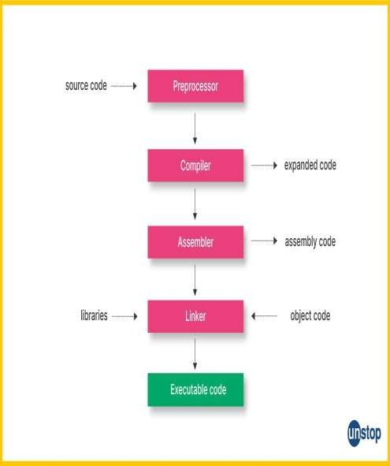

## Example of Canadian Cross, schemeANALYSIS:

Cross compiler development analysis involves a comprehensive examination of the process, challenges, and outcomes associated with creating compilers capable of generating code for disparate target platforms. It encompasses an evaluation of the underlying principles of compiler construction, such as lexical analysis, parsing, optimization, and code generation, in the context of cross-compilation. Key considerations include the selection of suitable toolchains, encompassing compilers, linkers, and other necessary tools, with a focus on compatibility, performance, and target architecture support. The analysis delves into architectural decisions, including the organization of front-end and back-end components, optimization strategies, and support for language-specific features. Challenges related to porting libraries, headers, and platform-specific APIs to the target environment are examined, along with strategies for ensuring compatibility and functionality.

## RESULT:

The result of cross compiler development is the creation of a sophisticated tool capable of translating source code written in one programming language into executable code for a target platform different from the development environment. This achievement represents a significant milestone in enabling software developers to write applications that can run on diverse computing architectures, from embedded systems to specialized hardware

The primary outcome of cross compiler development is the provision of enhanced flexibility and portability for software projects. Developers can leverage cross compilers to build applications for platforms with distinct architectures, operating systems, or hardware constraints, expanding the reach and accessibility of their software across various devices and environments.

In summary, the result of cross compiler development is a powerful tool that empowers software developers to create high-quality, efficient, and portable applications capable of running on a wide range of computing platforms, ultimately driving innovation and advancing the field of software development.

## CONCLUSION:

In conclusion, cross compiler development represents a critical facet of modern software engineering, enabling developers to transcend platform limitations and create versatile applications capable of running on diverse computing environments. Through the meticulous design, implementation, and optimization of cross-compilation tools, developers can overcome the challenges posed by varying architectures, operating systems, and hardware constraints..

## REFERENCES:

1. Aho, Alfred V., Monica S. Lam, Ravi Sethi, and Jeffrey D. Ullman. "Compilers: Principles, Techniques, and Tools." Pearson Education, 2006.
2. Fraser, Christopher W., and David R. Hanson. "A Retargetable C Compiler:

Design and Implementation." Addison-Wesley, 1995.

1. Fischer, Charles N., and Richard J. LeBlanc Jr. "Crafting a Compiler with C."

Pearson Education, 2009.

1. Kasper, Peter R., and Olav Beckmann. "Building an Optimizing Cross Compiler." Linux Journal, August 2001.
2. Yaghmour, Karim. "Building Embedded Linux Systems." O'Reilly Media, 2008. While not specifically focused on cross compiler development